Task 1: Simple Firewall program

Screenshots:

Running the program:

After the running the program we will hello world as output, which we can see using dmseg



When we remove the module we will get bye message, To remove the module we use bellow commands:



Task 2.1: protecting router

Screenshots:

Running iptables commands

Trying to ping and telnet:

Task 2.B

Screenshot

Running the commands

Trying to ping eth0:

Outside hosts can ping the router:

Internal hosts can ping outside hosts:

All other packets between the internal and external networks should be blocked.

Running commands:

Trying to access outside host

Task 3:

ICMP experiment:

ping 192.168.60.5 on 10.9.0.5

Checking the time using conntrack tool:



UDP experiment:

start a netcat UDP server:

send out UDP packets:

Tracking Screenshot:



TCP experiment:

start a netcat TCP server:



send out TCP packets:



Task 3.b:

Checking Conntrack:

Running iptables commands:



Checking rules:

Screenshot 1:

Screenshot 2:

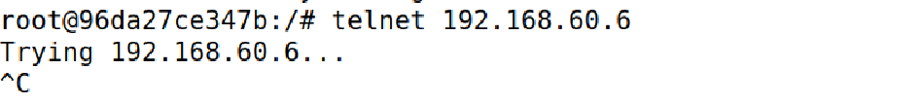

Task 4:

Screenshots:

Rule 1:



Checking above rule:

Rule 2:



Checking rule 2:

Task 5:

start the server on each of the hosts:

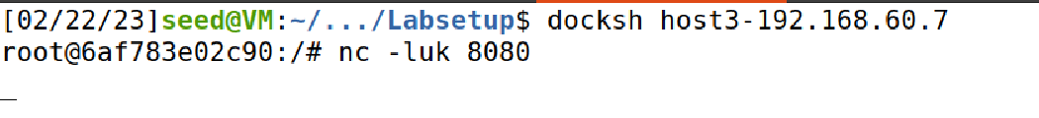



Running the rule:

Sending UDP packet:

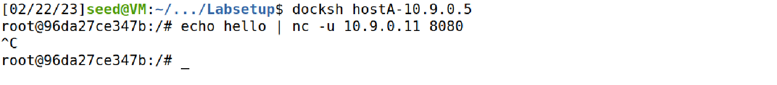

We added a rule for only 192.168.60.5 so we can see the out put on that host:

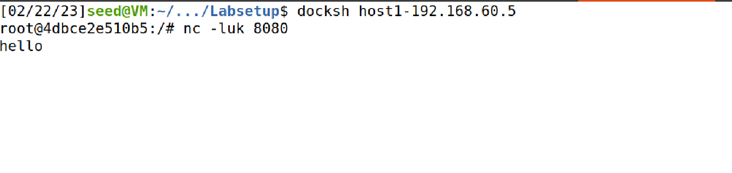

Adding the rule to all hosts:

Now checking the hosts:

Host 1:

Host2:

Host 3:

Using random mode:

Commands:

Hosts screenshot:

Host 1:

Host 2:

Host 3:

